About This Template
This press release template is designed to help new designees announce and promote their professional achievement. By filling in the placeholders with your personal details (name, organization, city, and date), you can easily share your accomplishment with local media, industry publications, and on your professional platforms. The template highlights the rigor of earning your designation, explains the criteria, and emphasizes your ongoing commitment to continuing education—positioning you as a trusted, knowledgeable professional in the insurance and risk management industry.
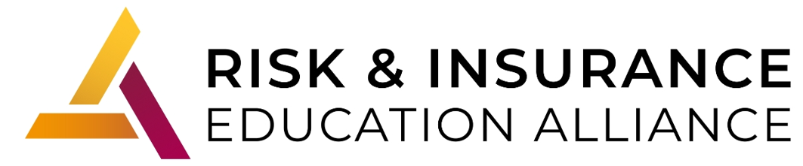
FOR IMMEDIATE RELEASE
[Your Name] Earns RiskPRO Certification
[City, State] – [Date] – [Your Full Name], of [Your Agency/Organization Name], has successfully completed the requirements to earn the [Contractors RiskPRO / Restaurant etc.] Certification through the Risk & Insurance Education Alliance.
The RiskPRO Certification program is designed to deliver highly specialized knowledge for professionals serving clients in specific industries. Each program is developed and taught by experienced practitioners, ensuring participants gain real-world insight into industry exposures, coverage gaps, and risk management strategies.
By earning the RiskPRO Certification, [Last Name] has demonstrated a commitment to providing industry-specific expertise and risk solutions that help clients reduce exposures and protect their businesses. This achievement highlights [his/her/their] dedication to professional growth and delivering exceptional value to clients.
The RiskPRO Certification is part of the Alliance’s commitment to providing practical, practitioner-led education that supports the evolving needs of the insurance and risk management industry.

About the Risk & Insurance Education Alliance
For more than 50 years, the Risk & Insurance Education Alliance has been dedicated to advancing the insurance and risk management industry through practical education taught by practitioners. From nationally recognized designations to industry-specific certifications, the Alliance equips professionals with the knowledge and tools they need to serve their clients and communities with confidence.

